Notre Dame 2020 MSBA Program

Qualtrics Import and Actions

Booz Allen Hamilton

Table of Contents

**Importing Surveys** 2

**Creating Actions** 3-4

# **IMPORTING SURVEYS**

**Link provided below accesses Qualtrics online *How to Guides* directly**

* [**Qualtrics - Importing Surveys**](https://www.qualtrics.com/support/survey-platform/survey-module/survey-tools/import-and-export-surveys/)

**Steps:**

1. Login to Qualtrics XM and click on “Projects” tab in the top right
2. Click on “Create new project.”

1. Under “Create your own” click “**Survey**.”
2. Name the project as associated with the survey being uploaded.
3. After project has been named, click on “from a file” and upload the survey associated with the project. These surveys are in the folder “Qualtrics Survey Uploads.”
4. Repeat these steps for a total of three times for each survey (PAX, coaches, and AAR)

# **Creating Actions**

**Disclaimer:** This will only be **necessary** if a question is added to the survey or the response type is modified. The “actions” function within Qualtrics is to initiate the API URL upon survey completion to trigger the code within AWS Lambda which will push survey data into a database. **Python code in AWS Lambda will need to be updated first to account for the added question. Once you have setup AWS Lambda and API gateway under your credentials, you will need to update the URL for each action in Qualtrics and replace with new URL outputted from API Gateway.**

**Link provided below accesses Qualtrics online *How to Guides* directly**

* [**Qualtrics - Actions**](https://www.qualtrics.com/support/survey-platform/actions-module/setting-up-actions/)

**Steps:**

1. Login to Qualtrics XM and click on “Actions” tab in the top right
2. Click on the associated action that needs modification
3. Hover and click on” Web Service.”

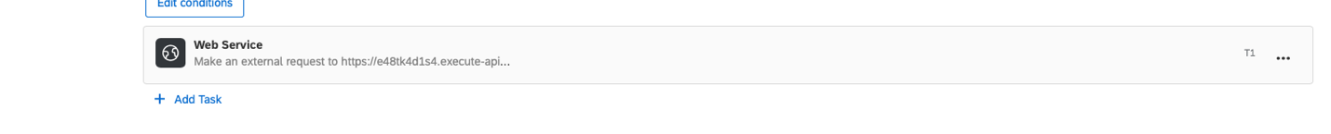

1. Scroll down to **+ ADD Data**

1. The “Key” value needs to match exactly what the Python code (AWS Lambda) name is in the str event (Example “wma”).

1. Click on the “{a}” dropdown on the value side. Pipe text from a survey question and find the associated added question that was added to the survey. Select “Selected Choices” for all questions other than text entry. Text entry questions will need to choose “Entered Text.”

1. Repeat as many times as needed to account for new questions and modifications.